**Leader Overview**

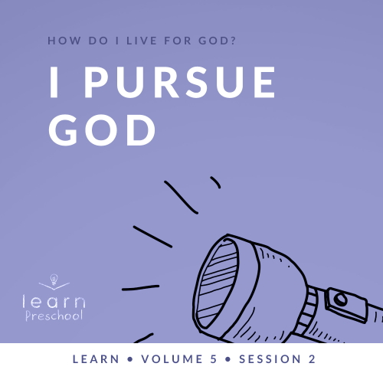

**Volume Overview**

**How do I live for God?**

*As we learn how to live for God, we’ll explore what that looks like in our everyday life. We know the Bible speaks to us, and God wants each of us to live connected to other believers. So, if that’s all true, how do we put God first? How do we get through all the confusion and uncertainty in this world? What does God expect when it comes to giving? How can we show others we care? In these sessions, we’ll consider what the Bible has to say in response to very important questions like these*.

**Session Overview**

**I Pursue God**

*In this* **Learn** *session, preschoolers will discover what it means to pursue God. One of the ways we pursue God is by talking to Him. Jesus very clearly teaches us how to pray in the New Testament. Preschoolers will learn that they can talk to God at any time, no matter what they are doing. He is always there*.

**Bible Lesson**

The Lord’s Prayer

[Matthew 6:5–18](https://ref.ly/logosref/Bible.Mt6.5-18)

**Faith Fact**

I can talk to God.

**Faith Verse**

[Matthew 6:33](https://ref.ly/logosref/Bible.Mt6.33) (NLT)

“Seek the Kingdom of God above all else, and live righteously, and he will give you everything you need.”

**Preparing for the Session**

**Leader Preparation Time: 20–25 Minutes**

|  |
| --- |
| ***You Will Need***  ***Preservice Activities***  *• Leader’s Choice for snack*  *• Toys*  ***Large Group***  *• Bible*  *• Worship songs (Song suggestions: “What a Mighty God We Serve” by Listener Kids; “Brave” by Saddleback Kids; “No Fear in Love” by Elevation Church Kids)*  *• For groups not using a phone or tablet only, add:*  *• Projector or TV*  *• Laptop*  *•* ***Faith Fact Sound*** *video (bell ringing)*  *•* ***Faith Fact Slide***  *•* ***Faith Verse Slide***  *•* ***Bible Lesson Video A***  *•* ***Bible Lesson Video B***  ***Small Group***  *• Soft ball*  *• Music and a way to play it*  *•* ***Small Group Activity Page****, one per kid*  *• Pencils, one per kid*  *• Crayons or markers*  *• Completed* ***Small Group Activity Pages***  *To access session content and videos from a computer, visit:* [*BibleEngagementProject.com/downloads*](https://bibleengagementproject.com/downloads) |
| ***Getting Ready***  ***Preservice Activities***  *• Set out toys and snacks.*  ***Large Group***  *• Download videos and slides if needed.*  *• Select worship song(s) and have them ready to play.*  ***Small Group***  *• Print copies of the* ***Small Group Activity Page****, one per kid.*  *First time leading* Learn *for Preschool? Check out the* [Facilitator Guide](https://0b769b0ed3569ef9d18b-f88d8272f61086866d50d048b43ef630.ssl.cf2.rackcdn.com/sites/biblengagementproject/Listen_Facilitator_Guide.pdf). |

**Preservice Activities**

*See what’s needed at the beginning of the session.*

**Bible Story Warm-Up**

*Have kids sit in a circle as they come in*.

Today, we’ll learn something very important. It’s a lot like something that we already do throughout the day, but we’ll learn to do it with a special purpose. All day long we talk to people. Today, we’ll learn about talking to God.

First, let’s play a game. I’ll whisper something to one of you right now. Then, I want you to whisper it to the person sitting next to you. Everyone will keep passing along the message until it gets back to me. Let’s see how we do.

• *Tell one kid a simple phrase that everyone will understand: God loves you*.

• *When the last kid tells you the phrase, say it out loud for everyone to hear*.

That was fun! Let’s try it again, but this time we’ll make it harder. It might not even make sense when you hear it. Listen closely. Then, tell the next person what you think you heard.

• *Share something silly: Jumping jelly beans make me run fast*.

• *When the last kid tells you the phrase, say it out loud for everyone to hear*.

That was a lot harder, wasn’t it? *(Group response)*. Would it have been easier if I told everyone the message at the same time? *(Group response)* It’s hard to talk when you have to go through other people to pass a message. God wants to make things very easy for us to talk to Him. Today, we’ll learn that we can talk to God when we pray.

Do you already pray and talk to God?

What can we talk to God about?

When can we talk to God?

I love that we can always talk to God. We can talk to Him when we wake up, when we’re going to sleep, and all throughout our day. Did you know that God loves it when you talk to Him? I can’t wait to learn more about this today with you.

**Snack**

**Leader’s Choice**

Since we’re learning about talking to God today, I think we should do that now. Before we have our snack, let’s pray.

|  |
| --- |
| Dear God, thank You for letting us be here today to learn more about talking with You. Thank You for this snack we’re about to eat. We love You. Amen. |

• *Pass out the snacks*.

• *As kids are eating, share the following:*

Have you ever prayed for someone?

Who did you pray for?

Is there ever a bad time to talk to God?

Is He ever too busy to listen?

I’m glad God is always here to listen to you and me when we pray. I can’t wait to find out more about talking to God.

**Free Play**

*Any extra time can be spent playing with toys*.

**Transition**

*A few minutes before service begins have kids make their way to the large group area and sit in their designated areas*.

**Large Group**

**25 Minutes**

*See what’s needed at the beginning of the session.*

**Introduction**

Hey, everyone! I’m super pumped that we’re about to do one of my most favorite things ever! We’re going to learn about God’s Word. *(Hold up the Bible.)* If you’re excited to learn more about the Bible, raise your hand. *(Group response)*

The Bible teaches us how to live for God. It shows us how to follow God and how to love others. The Bible also teaches us that we can talk to God. Today, we’ll learn why it’s important to talk to God. We call that prayer. We can always talk to God.

**Faith Fact**

In fact, that’s what our Faith Fact says. **I can talk to God**.

• *Show the* ***Faith Fact Slide***.

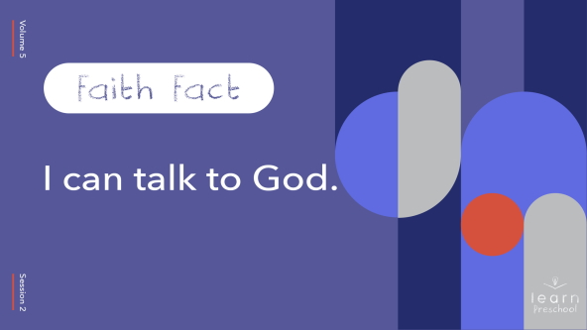

Let’s say our Faith Fact together. Pretend you have a megaphone over your mouth.

• *Demonstrate by cupping your hands around your mouth*.

A megaphone helps you to say things louder, so more people can hear. The first time we say our Faith Fact, let’s pretend our megaphones are broken. Say the Faith Fact as quietly as you can. Ready? **I can talk to God**.

Awesome! This time let’s pretend our megaphones are working great. Let’s say the Faith Fact as loud as we can. Ready? **I can talk to God.** Yes! Let’s do it one more time. **I can talk to God.** Great job!

**Bible Time**

One of the best things that we can do together is learn about God and His Word. I’m so glad we have someone to help us do that. Let’s check in with Lizzy today.

• *Play* ***Bible Lesson Video A***.

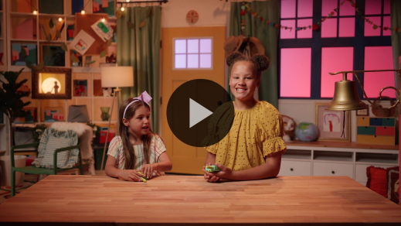

Wow! You did a great job helping Lizzy solve all the clues today. In our Bible story, Jesus taught us how to pray. How cool is it that? Jesus, God’s Son, took the time to teach us how to pray.

Jesus told us we don’t have to pray big, crazy, loud, or long prayers. We can simply talk to God. He even gave us an example of how to pray in the Bible. We can look at what God’s Word says about prayer when we don’t know how.

When we pray, we need to remember that what we’re doing is talking to God. We can talk to Him anytime during the day or if we wake up in the night. God is always ready to listen to us.

**Worship**

When we come to church, we often learn about God and how much He loves us. When we stop and take time to worship, we actually get to tell God how much we love Him. Worship is another way that we can talk to God. It’s one way we can tell Him how great and wonderful He is. I love that we can talk to God.

**Praise**

Are you ready to worship God today? Clap your hands. *(Group response)*

Are you excited that you can talk to God? Point up high. *(Group response)*

Who wants to tell God you love Him? Point at your chest and say, “I do! I love You, God!” *(Group response)*

**Sing**

One way we worship God is by singing. These words we sing can come from our heart to tell God how much He means to us. As we sing, let’s all focus on God.

• *Lead the kids in singing one or two songs. See song suggestions at the beginning of the session*.

**Prayer**

Wow! I love to listen to you sing! I love watching you worship God, and I know God loves it, too. There’s something so special when we stop what we’re doing and focus on how big and great God is. Let’s continue to focus on God and practice talking to Him. Let’s bow our head and pray.

|  |
| --- |
| Dear God, thank You for always being with us. I love that we can talk to You and that You always listen. Help us to remember that we can always talk to You about everything. We love You, God. Amen. |

**Bible Time cont’d**

As much as we love talking to God, He also loves to talk to us. One of the ways God talks to us is through the Bible. Let’s see if Lizzy will help us with our Faith Verse from the Bible.

• *Play* ***Bible Lesson Video B***.

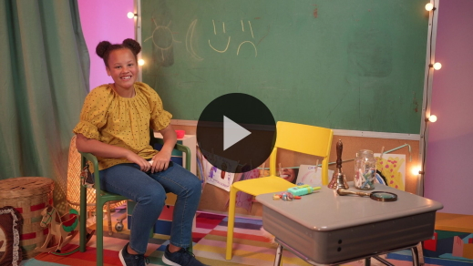

Yippee! You’re doing so great at learning your Faith Verse! Soon you’ll be teaching it to me.

Who has loved learning about the Bible today? *(Group response)* Me too! Let’s review our Bible story.

Who taught us how to pray? *(Allow responses.)* That’s right! Jesus did. He knew sometimes we would forget the purpose of praying or maybe get confused, so He gave us an example of how to pray.

Where can we find out what Jesus taught about prayer? *(Allow responses.)* In the Bible, Jesus reminded us that when we pray, we shouldn’t do it for other people to see. We should do it for God. We don’t have to worry about other people or what they think of our prayers because we’re talking to God. He loves it when we do that.

**Response Time**

• *Play a worship song quietly*.

We’re going to take a few moments to respond to what we learned. Hold your hands like you’re going to pray.

• *Demonstrate how you want kids to pray*.

Good job! When we hold our hands like this, it keeps us from being busy doing other things. Closing our eyes helps us focus on God. Now, let’s talk to Him.

• *Optional: Have the kids repeat phrases of the prayer after you*.

|  |
| --- |
| Dear God, I love to talk to You. Help me to remember that I can talk to You about everything. I can talk to You all the time. You’re never too busy for me. Thank You for listening when I pray. Amen. |

**Faith Verse**

Did you know that God loves for us to learn His Word? He loves it when we memorize the Bible, so let’s practice our Faith Verse together.

• *Show the* ***Faith Verse Slide***.

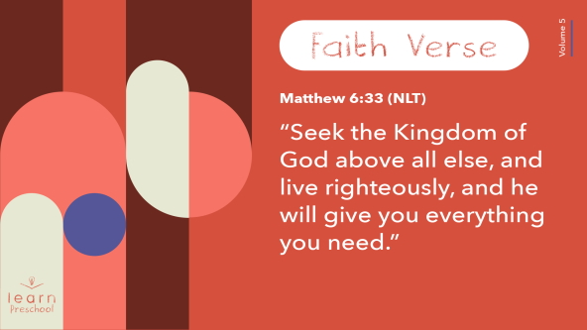

[Matthew 6:33](https://ref.ly/logosref/Bible.Mt6.33) (NLT)

“Seek the Kingdom of God above all else, and live righteously, and he will give you everything you need.”

**Matthew** *(hands at waist, spread apart, palms up and out)*

**6**: *(hands together like a clap)*

**33** *(hands opened to “book”)*

**“Seek the Kingdom of God** *(one hand at brow, “search” left and right)*

**above all else**, *(point up with both index fingers)*

**and live righteously**, *(clasp hands in prayer waist-high)*

**and he will give you** *(open hands flat at waist)*

**everything you need.”** *(move hands out to side and then clap)*

Amazing! You’re doing so well at learning our Faith Verse.

**Closing**

Who learned more about God today? *(Group response)* Me too! I love that we can always learn more about God. I also love that the Bible teaches us how to live for Him. Today, the Bible taught us about prayer. Talking to God is so important that Jesus taught us how to pray.

• *Play the* ***Faith Fact Sound*** *video (bell ringing)*.

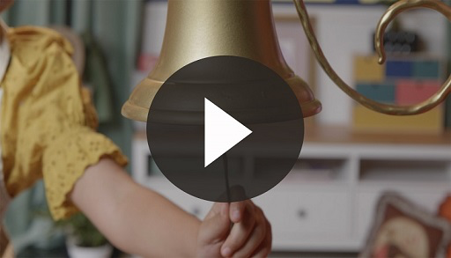

That sound means it’s time to say our Faith Fact.

• *Show the* ***Faith Fact Slide***.



Let’s shout it together. Ready? **I can talk to God**. Get those megaphones out again. *(Cup hands around mouth like a megaphone)* Now, let’s say it as loud as we can. Ready? **I can talk to God**.

**Dismissal to Small Groups**

Fantastic! It’s time for small group circles so we can have fun and keep learning about God!

• *Dismiss the kids by groups*.

|  |
| --- |
| ***Leader Tip:*** *This can be done by assigning color teams or by age groups. Note that some young preschoolers may not know their age. Using a colored sticker, jersey, or wristband will help separate the kids and help identify their small groups.* |

**Small Group**

**25 Minutes**

*See supplies and prep instructions at beginning of session or in each activity below.*

|  |
| --- |
| ***Leader Tip:*** *Small groups can alternate to each circle, or all groups can do each activity at the same time. If you choose to alternate, you will need at least one leader per circle.* |

**Circle 1**

**Group Connection**

**Hot Potato**

|  |
| --- |
| ***You Will Need***  *• Soft ball*  *• Music and a way to play it*  *No prep needed for this activity.* |

Let’s think about our Faith Fact. What is it? **I can talk to God**. Prayer is so important that Jesus taught us how to pray. That’s pretty awesome. Talking to God is very important, so we need to make sure we remember the Faith Fact.

• *Have kids sit in a circle*.

• *Hold up the ball*.

I’m going to hand one of you this ball. You’re going to pass it around the circle while the music plays. When the music stops, whoever has the ball gets to say our Faith Fact. Let’s practice the Faith Fact one time before we start. Ready? **I can talk to God**. Great job! Now who’s ready to play? *(Group response)*

• *Hand ball to first kid and start the music*.

• *Stop the music and call on the kid with the ball to say the Faith Fact*.

• *Keep playing until you are almost out of time*.

Great job! There’s no way you’re forgetting today’s Faith Fact. Would you like to play again, but make it harder? *(Group response)* We’ll play the same way. If you have the ball when the music stops, you’ll say the Faith Fact. If someone says it faster than you, you’ll be out. We’ll keep playing until there is only one person left.

• *Play until the game is over*.

**Circle 2**

**Activity Page Time**

**Prayer Request**

|  |
| --- |
| ***You Will Need***  *•* ***Small Group Activity Page****, one per kid*  *• Pencils, one per kid*  *• Crayons or markers*  ***Getting Ready***  *• Print copies of the* ***Small Group Activity Page****, one per kid.* |

Our Faith Fact today is about talking to God. Raise your hand if you can talk to God. *(Group response)* Yes! We all can talk to God. On your paper, the words start with our Faith Fact written out in dotted lines.

• *Hand out a* ***Small Group******Activity Page****, a pencil, and crayons to each kid*.

The page says, “I can talk to God about …” I want you to trace the letters. When you’re done, draw a picture of something you want to talk to God about. Maybe you know someone who is sick. You could draw a picture of that person. Maybe there is something special you’d like to do with someone. Draw a picture of that. Whatever it is, God wants to hear from you.

• *When the kids finish their page, collect the papers because you will use these pages in Hands-On Learning*.

• *During the activity, interrupt and practice the Faith Fact:* **I can talk to God**.

• *Play the* ***Faith Fact Sound*** *video. Review the Faith Fact even if you can’t play the sound*.



That’s terrific! You did a great job writing your letters and drawing what you want to talk to God about.

**Circle 3**

**Feet-to-Floor Game Time**

**Stop and Pray Freeze Tag**

|  |
| --- |
| *No prep needed for this activity.* |

Have you ever tried to put something together but didn’t know how? *(Group response)* Maybe you were trying to learn something new but needed some help. Did you know that Jesus knew we would need some help? *(Group response)* That’s why Jesus gave us instructions in the Bible about how to pray. He wanted to help us talk to God.

We can pray to God anytime we need some help. Let’s think about that as we play a game. Who’s ready to play? *(Group response)* Awesome! This game will help us remember that we can talk to God no matter what’s going on. We can stop and pray, and God always listens.

One person is going to be “It.” Their job is to tag you. If you get tagged, you’ll freeze in place and put your hands in a praying position. *(Demonstrate prayer position.)* You can only get unfrozen if someone taps you and says, “**I can talk to God**.” Then, you get to play again. Let’s play.

• *Choose different kids to be “It” as you play*.

You’re so fast! I loved listening to you say your Faith Fact while you were helping your friends get unstuck. It’s a great reminder that we can always talk to God when we need help.

**Circle 4**

**Hands-On Learning**

**Prayer Time**

|  |
| --- |
| ***You Will Need***  *• Completed* ***Small Group Activity Pages***  *No prep needed for this activity.* |

Today, we learned that we can talk to God, so that’s what we’re going to do right now. You drew a picture of something that you want to pray about on your ***Small Group Activity Page*.** We’re going to pray together for those things.

When it’s your turn to tell us about your prayer need, you can decide if you want to pray for it or if you want me to. Remember, prayer is just talking to God like I’m talking to you right now. Then, we’ll all pray together. We can pray for the needs of our friends, too. God is always here, so He will listen to our prayers.

• *Let each kid share their prayer need*.

• *Pray for that need. If kids aren’t comfortable praying, offer to let them repeat after you*.

When we pray it connects us to God. He always hears us.

**Dismissal**

• *Play the* ***Faith Fact Sound*** *video (bell ringing)*.



• *Show the* ***Faith Fact Slide***.



Everyone, let’s say our Faith Fact. Freeze in place and clap your hands together like you’re going to pray. Then, let’s say the Faith Fact one last time. **I can talk to God**.

Great job! I had a fun learning more about God’s Word with you. See you next time.

• *Send home the* ***Small Group Activity Page*** *with each kid*.

• *Remind parents that there are* ***Family Devotions*** *available on the app to do with their kid*.

• *Tell everyone the date and time for the next session*.